AAGP Construction Notes

Section Links – ctrl+click on the section titles | Page
SERVER NOTES (OVH) | 1
XARA INSTALLATION & NOTES | 2
GENERAL NOTES | 2
MEMBERS PAGES | 2
FORMS USED on the site | 3
KEEPING THE SITE UPDATED inc MONTHLY UPDATES | 5
THE PROCESS | 5
NEWSLETTER with MS PUBLISHER | 6
BIG NEWSLETTER with MS PUBLISHER | 8
MAIN and MEMBER WEBPAGES with XARA | 11
TESTING | 11
PUBLISHING | 11
SEND EMAIL | 12
ACCESS TO PRIVATE PAGES – PASSWORD PROTECTION | 13
AAGP GROUP MAILING LISTS | 20

Apps used at present are:
Xara Web Designer 20 – copy purchased by AAGP – see below for download & activation
FileZilla – freeware: https://filezilla-project.org/
A pdf reader and a pdf converter of images to jpg or other picture format. I use PDF Architect.
MS Paint – to reduce pictures to thumbnails
MS Word
MS Publisher
MS Notepad or other text editor

TO DO list
- Maybe put a comment in the members pages saying list of committee members is at…..?
- Redesign
- Click on AAGP logo to return to front page of each section?
- Each year update the copyright note at the footer
- Error in Members’ page – Activities page – see

SERVER NOTES (OVH)

The website has historically been held on the servers of OVH.com. It was set up with them in 2008 when the site started. The host could be changed as required.

Login and FTP details are held on the document “Website - FTP & OVH details.docx”. As are other notes relevant to site hosting.

In FTP do not delete the two directories www and cgi-bin:
- www is meant to host your web pages (* .html * .php)
  - the pages will be visible using the following address: http: //www.votre-domaine.tld/
- cgi-bin can be used to install some cgi scripts http: //www.votre-domaine.tld/cgi-bin

For hosting 60gp type (and therefore not mailplans):
in the www / panel directory (http: //www.your-domain.tld/panel), are some useful scripts (use your login and your password to access it):
- phpmyadmin: manage your MySQL database
- http: //www.votre-domaine.tld/panel/phpmyadmin
XARA INSTALLATION and USAGE NOTES:

XARA Web Designer Premium is the software package used at present for the AAGP site. V20 was purchased on 17 April 2025 for €119.40 (€99.50 + VAT). It allows (exceptionally for us) 3 users simultaneously. To get further updates we may need to subscribe (at new – Oct 2025- prices €8/month) payable in annual lumps. https://www.xara.com/webdesigner/v20/:

Used this coupon code when purchasing v20: PERPETUAL-NFP
Our contact at Xara was Matt - matt@xara.com or matt.bolton-0438bb1a8064@xara.intercom-mail.com
He gave us a 50% discount – if we move to the annual subscription we should ask for it again.
Invoice # 37385; Customer ID 6old0SpWnL9ed2T8
It was billed to: Tim Williams, AAGP, 13 Chemin 3 Moulins, Batiment F, Aix en Provence, 13100, France
+33672827277. tim@ringsteadbay.com

Installation: ‘Xara Web Designer 20’
- Setup file is: XWDL20Setup.exe – in the WeTransfer link that Tim sent
- install Xara then start it up. It will ask for email to activate
- Sometimes i have to restart computer to get XARA to open and then it also asks for signin.
- Use email ‘tim@ringsteadbay.com
- Use Password: AAGPWebmasters25
- 3 devices can use this package simultaneously even though it says 2 – see Matt’s email above. When my laptop crashed I talked to Matt and Xara removed the old computer from their list so I could install it on the new one. It was a bit convoluted in the end but….. it worked!
- If it asks for email address. use: tim@ringsteadbay.com

When opening, it may ask if you want to update version – just say NO and keep on saying NO – not necessary
Xara is reasonably intuitive and permits the use of some advanced and attractive features not possible on free sites (2020). However this functionality may change and it might be good to move to a freely available App like WIX or WORDPRESS (free version) in due course to simplify any change of webmaster.
This would probably require a complete re-construction of each page so will not be a trivial task!

Xara automatically generates 2 versions of website pages – the full size [Main] and the small screen size [Mobile] which come up as separate tabs on the App. Its not brilliant and you have to check if changes in the Main version have translated to the Mobile one. There are some fixes to make it work – see the notes below on the ACTIVITIES page.

Normally Xara can be made to do what you want with the same tricks as MS word etc but sometimes not and it then requires a bit of ingenuity – or ask one other other Webmasters….

When using Xara these notes may save some frustration:
The XARA help pages and Manual (click on the “Help” menu) which you can download from the XARA site are OK but not great. You may have to search the web and be a bit intuitive.

If you cannot see content on a page check that the “MouseOff” layer is visible (column on right hand side with page expanded)

GENERAL NOTES
- Standard text is Times New Roman 20 on all pages and on [Mobile] pages
There may be a legacy of Arial 20 on some pages
- To generate the “Forms” used I have used free ones from …. Jotform.com. We can discuss this as there are issues! And I have not yet recorded them….. see the general notes below.
Go To Page 1
- If you find photos on the publisher version which you cannot select by clicking on it (or a group) when you want to re-size or move it/them, then do a group select by using the cursor to define a box area over it /them (start off the active text area) then right click on one of the corner points, Click on “Change Picture”, click on “Reset Picture”, - they will all go back to original sizes etc so you can re-size and position as required.
- To recover a crashed or unusable site:
I have not done this but have taken precautionary copies of the site contents. You should too😊
Try copying these back to the server site using Filezilla from the older Xara files saved on the server..

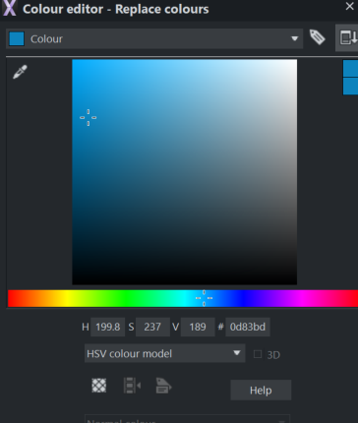
Action Buttons
The blue colour is H: 199.8 S: 237 V: 189 #: 0d83bd
Click on the “Click to edit current colour” button (bottom left)
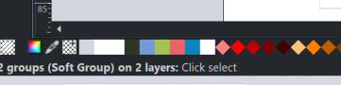
And the window for colour palettes appears. Click on the menu bar at the top of the window to select the item / colour to be edited – be careful it is the thing you want to colour, not the background etc.

Either note the numbers used so you can get the same elsewhere
Or change the numbers to the ones you want.
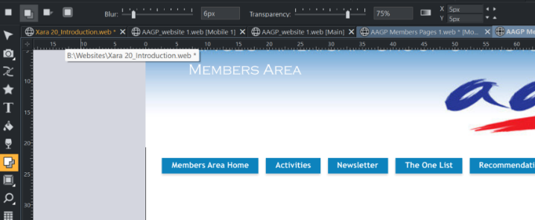
If shadow is needed Use the shadow tool on the left
and the shadow toolbar

To get all buttons with the same effects (mouseover, click etc) I tried all the menus, to no avail, then hit upon the idea that they might be made up in layers so opened up the “Page & Layer” gallery (on the right side of the screen) and there I found the breakdown of the buttons and an indication of the solution. See some of it below, but…….
……..In the end I copied the Calendar button (with the “mouseover” eye icon in Page & Layer closed (red) to ensure I got the whole group). Changed the text and the link and then, with the “mouseover” eye icon in Page & Layer open (grey), deleted the unwanted button and any elements that remained.

I had tried ungrouping the buttons and manipulating the 4 or so elements but that may be for another day! A taster is that to change the NavBar manually you need to click on the navigation bar, click on Edit Navigation Bar, and in Navigation Bar Properties (bottom Left) click “Ungroup to edit graphics”. Then use the “Page & Layer” gallery to break out the various colour and mouseover elements…… and work on them.
Go To Page 1
The alternative is to get the AAGP to subscribe to a €7.80 “Plus Annual Plan” for Xara which gives access to their XElements online content catalogue and constant access to the latest version, plus their modular website builder with “Blocks”. It might be worth a look – the content catalogue was used for the original version.
Below is the abortive attempt to play with individual layers and elements:
It is useful in that it shows how to adjust things, perhaps in another context.

I did a preview of the page at each stage of trying to manipulate the buttons to see what overall effect had been achieved – note that sometimes unexpected effects occurred and a lot of the “undo” arrow was needed.
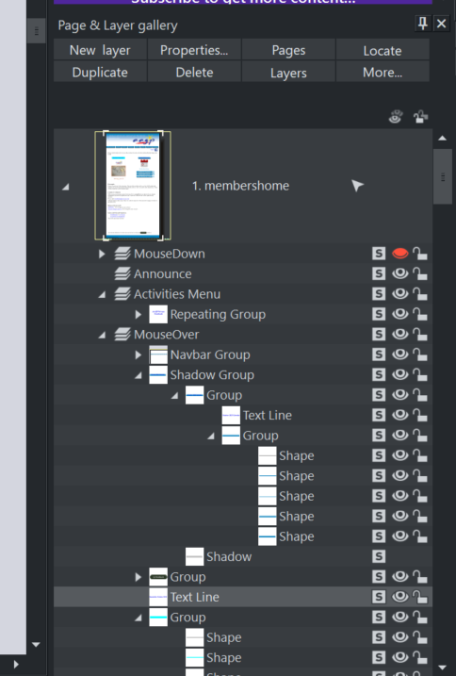
For the buttons which have an action on “mouseover” you’ll need to use the “Page & Layer” gallery (on the right side of the screen) to manipulate them

Open the arrowheads to see the various parts of the layers

- the mouseover effect is in the “Group” area
(if there is a shadow then it becomes the shadow group).

Turn the eyeball icon on and off to see the effect of each

The effect of what you show will appear immediately on the Xara screen so you can change colours etc as for normal editing – to edit directly from the Page & Layer window click on the “S”.

And so on……….

REFINEMENTS
Outline frame under where the newsletter thumbnail goes, centred on the button above. Light grey so can act as a shadow or an outline or be covered as appropriate.

MEMBERS PAGES
Go To Page 1
ACTIVITIES PAGE
- AAGP Members Pages.xar [Main] - Activities page has pop-ups for each activity box clicked on. The page list is on the right of the main window – Page & Layer Gallery. You can see all the pop-up layers on the list below “page 4.activities”red – click on the expand arrow by the page to see the pop-up elements and then on the red “eye” icon to see them – don’t forget to click it again when you have finished or when you publish the site the text/layer you just viewed will be published to the site and will show over any other selection on the Activities page.
- AAGP Members Pages.xar [Mobile] – NEWBUG! Activities page has a problem generated yesterday by me!!! I redirected the menu items to the pop-ups as above after an issue and not reading these notes again (Damn!) then I deleted the individual pages described here: ….individual pages available at the bottom of the set of pages. This avoided the issue with pop-ups where the pop-up will disappear if you touch/click on the page. Pop-ups are not activated on small screen pages - – leave them alone other than making sure the content matches So these need working on. DEALT WITH! – No problem but, yes, its easier to delete than re-create!! I have re-created all the Activities pages and labelled them with a “mobile” prefix. Having them as individual pages not pop-ups seems to be the only way to do it with the mobile drop-down.

FORMS USED on the site
5 forms (the maximum for a free account) are made using the free “JOTFORM” builder https://www.jotform.com/myaccount/profile
Login: tnehjw
Password: AAGPPr0vence
Email : timinaix@gmail.com
Account Type FREE
- 100 monthly submissions
- 10 monthly payment submissions
- 1,000 monthly form views
- 5 total forms
- 100MB total space
- 500 total submission storage
Currently using 5 forms:
- AAGP Small Ads mobile
- Small Ads Main
- AAGP Website feedback
- Small Screen AAGP – Contact us
- AAGP - Contact Us
To change the recipient of the submitted form, click and edit for the appropriate form, Settings, Emails, Notification 1 and change the mail address. There is no need to re-load the form to Xara! Just change the mail on the JotForm site.

If you want to add a form from Xara, click on Insert, Table, then scroll to Forms – click, click on JotForm, login , create or amend the form and “Publish”. At this point click on “Embed” and on “Copy Code” on the top option. Then click on Go or continue or whatever the button is at the bottom of the page…. Xara will then embed it.
Check you have all the elements you created – the formatting on the published page can be problematical so check everything on the web itself…

Membership application for a RIB/bank details were made using another JotForm account but the form is on hold for now
Login: AAGP
Password: AAGPPr0vence!
Email : aagpprovence@gmail.com

Go To Page 1
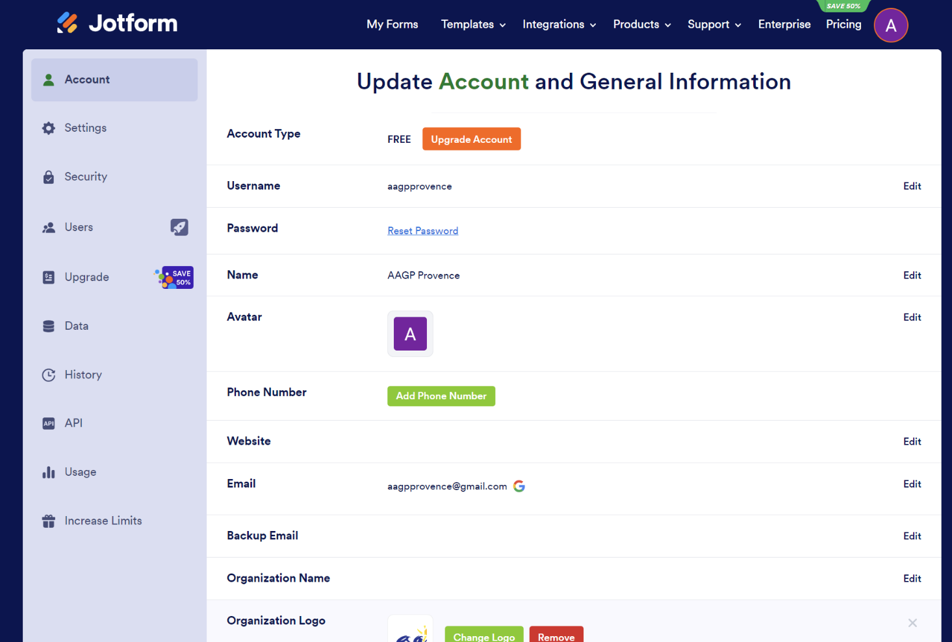

A Gmail account has been set up for AAGP so we can use Google Sheets etc
First Name: AAGP
Last Name: Provence
Username / mail account: aagpprovence@gmail.com
Password: Members0nly*
Phone number 6072827277
Recovery email: timinaix@gmail.com
Birthday 1 Jan 1980, Male
Go To Page 1

KEEPING THE SITE UPDATED

SITE BACKUPS
Take a backup of all files on the host server every 3 months. Hold these in case the site is corrupted or hacked.

THE PROCESS overview Each month
The elements:
The next months details come in between 18th and 23rd of each month in 2 or 3 emails from the Newsletter editors & Small Ads, and maybe others. Receive the following:
- Newsletter in MS Publisher format plus a PDF but this PDF is in the double page format used by the Print Shop, so is no use to you. You will need to generate a single page PDF to put on the website.
  - Create the correct format Newsletter in Publisher, save as a pdf (see below on how to do this).
  - Make the LARGE version for the hard of sight – also pdf it.
- Calendar sometimes comes in Word, sometimes just in PDF, sometimes both. Make a pdf of the calendar if not already done. Make a single page Large script version, and pdf it.
- Membership changes – sometimes with Calendar as page 2, sometimes separate, always in PDF. Should already be a pdf so make a Large version by whatever means you choose – I make an image of the page, place it in Word, duplicate it on the page, cut the image and expand the elements to give a BIG version then save it as a pdf.
- Small Ads arrive around 15th but sometimes don’t come in and you need to lift from the newsletter file
- Occasionally there will also be changes or additions to pages, contact details for activities, AAGP documents (eg AGM minutes) which need to be transferred by FTP (Filezilla) and have hotlinks updated.

Save where you wish on your AAGP Folders (feel free to change the structure I passed you – I used D:\AAGP\AAGP Documents\Newsletters\2024\2024 Newsletters\Publisher and similar folders for the others) re-name following the correct format (use the last month’s as a template).
The standard naming convention is NL-Month-Year.pdf and Cal-Month-Year.pdf Do not leave spaces or these show as odd characters when published.
in the website format to be transferred by FTP - Filezilla to the OVH servers.

The Website pages: Update links, Test and Publish (see below MONTHLY UPDATES Checklist)
- UPDATE (8) web LINKS (on mob n web) for Newsletter, Calendar, Membership monthly updates
- UPDATE Small Ads monthly updates
- UPDATE links and ADD any AAGP Documents
- TEST
- PUBLISH
- Place your months Xara files on the server for the next person to use to start their month.
- Weed the data on the server (using Filezilla) to remove Membership Changes outside current year

The email to web subscribers:
- See notes below on page 14 (or thereabouts)
- We have stopped using the mail list in OVH as it does not have DKIM verification so gets rejected by various servers. Now we use a Bcc mail to a list of email addresses from a Word doc on the server in the Xara pages folder.
- Place the list of names you used for the mailshot (as Bcc) on the server (with that month’s Xara files)
Go To Page 1

DETAILS for updating elements:
1) MAKE NEWSLETTER (use MS Publisher)(30m) Convert to single seq pages 1, 2, 3, ...etc in PDF format.

- Open the newsletter file (.pub) in MS PUBLISHER.
- Reduce image sizes: click to select first page photo/click on menu tab ‘Picture Format’/Compress Pictures
  - Target Output: ‘Web’; Apply compression settings now – ‘Apply to all pictures in publication’
  - Click ‘Compress’ button; ‘Compressing my reduce quality of your Images’ pop up – ‘YES’
- Save this as ‘NL-February-2025.pub’
- The pdf file is normally a copy of the file sent to the Print Shop in a booklet format – ie pages 1 /20 on one sheet, 2/19 on the next etc.
- “File” / “Export”
- Click on “Create PDF/XPS document” (Don’t hit enter yet)
- Select the destination folder (AAGP/AAGP Site Contents/Newsletters/2024/2024 Newsletters) for the PDF file in name format: NL-Month-Year.pdf ie: NL-July-2024.pdf
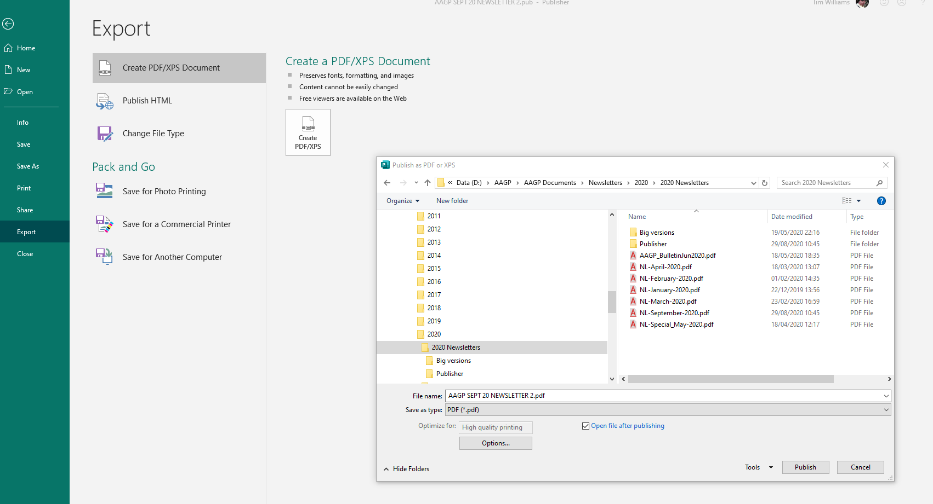
- Click on the Optimise for… Options… button which should appear when you choose PDF – at the bottom below “File Type”
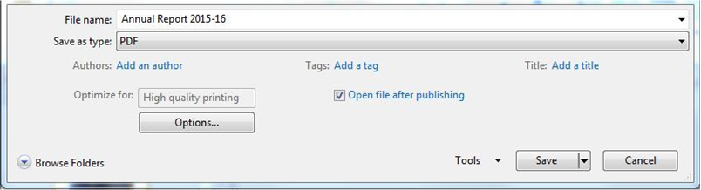
- The Publish Options window should open. Click on Print Options in the bottom-left corner.
Go To Page 1
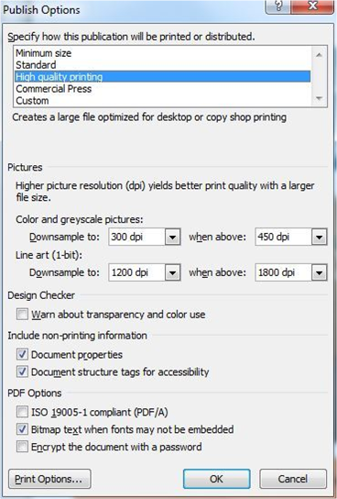
- Select “One page per sheet”, and save your document by clicking “OK”
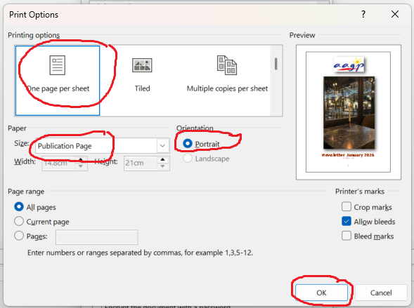
- Check standard name convention – no spaces!
- Then click “Publish”
- This should then be saved as a pdf file with one page per sheet suitable for placing on the website.
- Check the whole document in your PDF reader for black shadows blanks etc which occur occasionally when docs are transferred to PDF.
- Check the size of the Newsletter. Reduce if necessary to around 15-20 Mb
- use Filezilla to copy to server location /www/Members/Newsletters/year
Go To Page 1

2) make THUMBNAIL for Web (10mins)
- EITHER Export first page as pdf then convert to JPG
  - Search web for free PDF to JPG converter.
  - Reduce file size from original (100 – 400KB) to 20-50KB (for fast loading).
  - Microsoft “Paint” works fine – with a size reduction to 30 or 20%
  - or Gimp – try reducing to 400x600 pixels
- OR take snapshot (PC: ‘snipping tool’ or MAC: screenshot )
- save it somewhere for putting into members’ webpage later

3) make NEWSLETTER BIG PRINT (use MS Publisher) Increase print size in this version. (3 hrs)
- Copy compressed newsletter.pub or save new version of newsletter in publisher to naming convention:
  - ‘MON-YR_NEWSLETTER-LARGE.pub’.
  - ie: ‘JAN-24_NEWSLETTER-LARGE.pub’
- Change the page size:
- “Page Design” menu, select “Size”, select “Page Setup”, Select Layout type “One page per sheet”; change settings to width 15, (or wider if needed??) – height 40 ; margins minimal as you like; [check before clicking “OK” that the page size settings are still as above!!] .... click “OK”
- On “View” menu, select “Single Page”
- Go through each page - Change the font size (do it one page at a time, increasing everything by 4 points – (change main text from 12px to 18px (or 16px if needed)), remove excess line breaks, expand print borders, remove frills to get data on the pages. Mostly - keep the same data on the same page as the original - it makes it easier to check against the pdf version as you go through the layout. Challenges come when you have to re-size photographs and flow text around them – add suitable line breaks to keep it coherent. There will be a few hyphenated words but that’s OK. See ‘How to do it’ below for more details.
- Publish as before. (#1 Newsletter – 5export)
- Check the size of the Newsletter. Reduce if necessary to around 15-20 Mb
- use Filezilla to copy to server location /www/Members/Large_Text/year
How to do it:
- Have the normal PDF version open in a PDF reader so you can see which content fits which page
- The aim is to keep the same content on each page but if on some pages you need to over or under run for tidiness then so be it – but recover the space later or it gets complicated!
- Note: The Board letter on page 2 can often overrun and it can be challenging re-sizing the usual header and footer boxes – don’t sweat too much on these, concentrate on the actual content.
- Also, the “Regular Events /Useful Info” section comes in 2 columns – put it into 1 column and re-format, remove spaces/lines to make sense. (click inside text box, in tabs: click on ‘Text Box/ Columns/One Column’
- Move the text box to the top of the page. Or copy from previous month
- Consider removing any spaces above the first heading
- Highlight all text on that page (except for header and footer on Board Letter page)
- Increase text size by 4 clicks aiming for main reading text to be size 18 (check this as sometimes the version you get may be slightly bigger and only 3 clicks are needed)
- Increase the text box (top and bottom) to cover the full page (text for the next page will not be the increased size, at the bottom and this helps keeping the page similar to the normal PDF one). Check page content vs the PDF normal size version.
- Increase photo & image sizes as appropriate. Consider reformatting how the text runs around them (right click / Format Picture / Layout / Wrapping Style). The photos will look big on the page anyway due to the page format change but being bigger may help the hard of sight see details.
- Consider text justification for clarity – it normally comes as “Justify” but “Left” or others may be appropriate.
- On the “Whats On” pages you may need to be creative with venue and addresses formatting vis á vis photos to ensure clarity. Similarly with contact details at the bottom. Check line spacing and space after paragraphs on titles and reduce it to single line & no spacing, if you need to gain a little space.
Go To Page 1
- A tweak to help keeping everything on one page, if there’s lots of writing, can be to adjust the left and right text box edges to increase the line size. Or if the whole document is tight then increase the whole page width as in “Page Design” “Page Setup” above.
- Check for continuity – eg if only a signature line is being sent to the next page, adjust to try to condense
- In the “Looking Back” section, adjust photos as seems best for orientation / size etc – use your judgement! The text boxes may go AWOL or be a bit wild – see last sentence! It will help to refer to original PDF normal size.
- Other tricks for size and clarity: Reduce title size, reduce line title spacing, left justification, place pictures in centre with top & bottom text, squash the picture a bit in one direction (not for photos!) etc

*note – problem selecting photos or groups of photos on the publisher version?
- do a group select by using the cursor to define a box area over it /them (start off the active text area)
- or use control click to select multiple
- then right click on one of the corner points, Click on “Change Picture”, click on “Reset Picture”,
- they will all go back to original sizes etc so you can re-size and position as required.

*note – problem with text on photo that cannot reformat to a larger font or bunch of photos etc placed as a 1 page photo, the option is to copy them onto a word document, edit the image to make the text bigger (crop it out of a copy of the photo if needs be), reformat it on an A4 page or even larger,
- Export it as a PDF
- Use a PDF editor to add it to the Big Version newsletter PDF as a kind of merge - there will be 2 different
page sizes in it but at least it will be readable! Eg. see September 2021

4) make BIG Calendar (30mins)
- Get it in Word format. The calendar comes as a table
- Remove all spaces after each pages items ? Remove all spaces in filename.
- Format all text to 18 size – make the AAGP logo be “in front” of text (right click it, select “Wrap Text” from drop-down, select “In Front of Text”
- Rearrange the column spacing to avoid extra lines
- Reduce the font size of lines between activities to 8
- Remove any extra rows
- It should now fit onto 1 page....
- Save as MON-YR_CALENDAR_OF_EVENTS-LARGE.pdf ie: JAN-24_CALENDAR_OF_EVENTS-LARGE.pdf
- Transfer using filezilla to server folder: /www/Members/Large_Text/year

5) make Membership Changes (30 mins)
- These come as a PDF. They do not happen every month.
- To change it to larger format, convert it to a photo (JPG etc) file, place it into a Word document
- Copy the photo and place it lower
- Crop the title, then the contents as needed to double the text while keeping the format
- Export as a PDF
- Save as MC_Month-year.pdf ie: MC_November-2023.pdf
- Save as MON-YR_MEMBERSHIP_CHANGES.pdf ie: JAN-24_ MEMBERSHIP_CHANGES.pdf
- Transfer using Filezilla to Server folder /www/Members/Membership_Changes and /www/Members/Large_Text/2024

6) TRANSFER NEW ITEMS TO SERVER FOLDERS
If you haven’t done it already TRANSFER files (check naming convention) with Filezilla:
- Newsletter – check size as mentioned above. To /www/Members/Newsletters/year
- Calendar – check size in pdf as mentioned above. To /www/Members/Calendars/year
- Membership changes: /www/Members/Membership_Changes/year
- Large versions (Newsletter, Calendar, Membership Changes): /www/Members/Large_Text/year
- Add any new documents (AGM minutes, List of useful info etc)
Go To Page 1
7) MAIN WEBPAGE & MEMBERS’ PAGES (use XARA) – update links
Many of these changes can be prepared in Xara in advance of the files arriving from the Newsletter team.
First (transfer with filezilla) latest Xara files from server to your working directory
(note- sometimes xara has problems starting. Restart computer. then you might have to re-login to xara. See above login info: under Installation New Version: ‘Xara Web Designer 20’ – page 2)

Newsletter, Calendar, Membership monthly updates (approx 2-3 hrs w testing)
HOW TO update in XARA:
- To Select item to work on
  - click on ‘Select Tool’ (left margin toolbox: “Arrow” icon on top)
  - for images (especially in Archives page) you may need select camera icon (under Arrow Icon).
- Right click on selected item and from dropdown menu, select Web Properties at bottom which allows you to change the text, the link address and how it opens (new tab etc)
- Sometimes when you click on link, it opens small window which offers the option to change link.
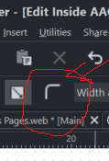
- Buttons – several types. Most basic is rectangle with text box on top.
  - Corner rounded – to remove, double click on shape (curve tool is selected) select you should see 2 ‘curve’ handles on each corner – select one handle and if you delete, corner becomes right angle.
  - Select Rectangle tool. In 3rd level top menu – select this icon: for making rounded corner (see image)
NB – Helpful Tips:
- It may be more time-efficient to update one link (eg the Newsletter link) copy the “Link to Web or Email address” text then use this on all the other places its required (main, thumbnail, mobile pages, archives…), then do the same for calendars etc.
- NOTE Some links are automatically transferred between the main & mobile pages.... and some are not -its all a matter of how it was set up and, to be honest, its all too difficult to try to make it all automatic!
- Groups are objects that act together – Arrange/Group or Ungroup. Ungroup to edit individual objects, and regroup later. (how to regroup the same way? It may have to be done the hard way!). Note that the name and icon for the 3 LARGE print items are grouped and the hyperlink to the page acts on the “Group”. The hyperlinks for the individual title and icons have been removed to avoid the old links they have causing confusion when editing later.
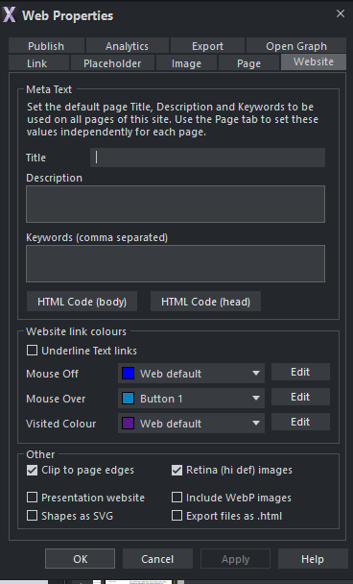
- How to edit hover color? Use the Web Properties box which comes up when you change the links etc.
- You need the Website tab:

Go To Page 1
CHECKLIST
☐ MembersHome MAIN (1a,1b,1c) | ☐ MembersHome MOBILE (1a,1b,1c)
☐ MembersHome MAIN (2 archives) | ☐ MembersHome MOBILE (2 archives)
☐ Website MAIN (3 Small ads) | ☐ Website MOBILE (3 Small Ads)

- Member pages: ‘AAGP Members Pages.xar’ [Main] and [Mobile] Page 1.membershome
  - Change the Newsletter thumbnail picture.
- TIP: Update the newsletter thumbnail photo on the [Main] Page 1.membershome. Copy it and paste it into the [Mobile] page 1, and on both main & mobile Archive pages but here set it behind the calendar logo which should show on top. Beware the month name in the archive block coming to the front! If it does, just delete it or it will mask the hotlink for the front page photo.
  - Change the month and year in the heading for Newsletter and Calendar –select text inside button
  - [Main] Pages Change all the links (8) to new pages for the month - (newsletter thumbnail, newsletter text button, calendar button, calendar icon, member changes, PLUS the 3 LARGE versions) – see sub-para e for instructions
  - [Mobile] Pages Change all the links (5) to new LARGE pages for the month - (newsletter thumbnail, newsletter text button, calendar button, calendar icon, member changes). We are now using the LARGE versions for the mobile page as these versions are much better on a mobile device. – see sub-para e for instructions
  - For changes to both Main and Mobile use this procedure:
    - right click, select “Web Properties” at the bottom, update the text in “Link to Web or Email address” – month and year.
    - Check the “Open Link in” is set to “New window or tab” to open in a new tab.

- Member pages: ‘AAGP Members Pages.xar’ [Main] and [Mobile] Page 6.archives
  - Add the new Newsletter front cover image
    - Either: “insert” the newsletter thumbnail onto the page and re-size + drag it on top of the appropriate space then right click it and “Arrange” it to go back a layer (or 2) so the red calendar icon is on top.
    - Or: make sure the camera icon on the left side margin is selected (under the arrow); click on the blank for the new magazine in the grid; right click on it and click replace photo.
  - Update these links to the newsletter and calendar as on the first page – ie using standard size for the Main page archive and LARGE ones for the Mobile archive (and yes, theat makes the standard page archive Calendar come out as LARGE but that’s just the way Xara does the mobile pages automatically in some areas – its fine as very few people look at it and the data is there.

- Public pages: ‘AAGP_website.web.xar’ [Main] & [Mobile 1] Small ads monthly updates
  - Change the heading to the new month
  - If the Small Ads are the same as last month (including if there are none) – all you need to do is change the month to the next one on the Xara pages 6 and 7.
  - Otherwise: Update adverts to the new data received and match the magazine
    - Inserting adverts - give phone numbers the web link property” tel:NNNNNNNN” and unclick “use common website link colours”. Also unclick “Correct Automatically”
    - For mail addresses use: mailto:xxxxxxx@xxxx.fr
    - Link all websites & email addresses but leave “use common website link colours” checked. Make all web pages open (Open link) in a “separate window or tab”
    - (Confirm common website colours for links is set to default – blue – on “websites” tab in “Web Properties” menu
    - Format: Line spacing at 110%. 0 space before or after lines
  - For [Mobile 1] site use the Xara Page 7.small ads-mobile with a cut & paste from the main Small Ads page but simply re-format as necessary for clarity on a mobile
  - On the website we also include the “Professional associations (English speaking)” notes in the Small Ads so they are on the public pages. These hardly ever change and can be checked in the PDF or MS PUBLISHER newsletter.

- AAGP Documents
Go To Page 1
- Place the extra AAGP docs in the file structure to make it easy to find, transfer to the FTP server and have a searchable record of each year later (not formally your responsibility but….)
- Update or add the links on the Xara pages to the new documents
- Transfer the files to the web server by FTP – Filezilla
- Place old document in the “Old Recommendations” or “Old Forms” etc as appropriate.

TESTING
Use the test page button to test all new links on main & mobile pages before you publish the site.
When you publish it check again live!
If a page “cannot be found” check the web address. If it has a “%20” in it – perhaps before a file name, then there is an unnecessary space in the hyperlink address.

PUBLISHING
Publication is around 27th of the month when the paper Newsletter arrives, but we can put it up earlier as one can see the old one in the archives.

To publish it there are 2 actions. One for each set of pages. The main and the mobile versions of each set of pages are published together as one when you click on publish for either..

In Xara, first save your pages. Then go to the “Share” tab, select “Publish Website”,
You will get presented, the first time, with a setup page in which you will have to enter the site details. Once entered (the next time) you will get this box (left for members pages, right one for public pages):
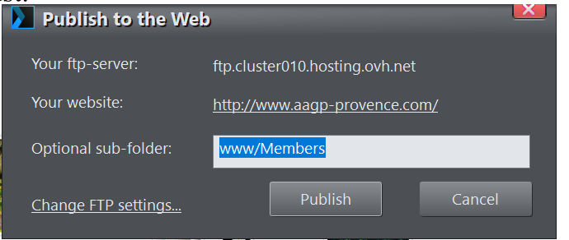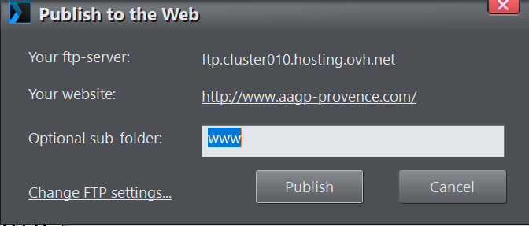

Followed by this one:
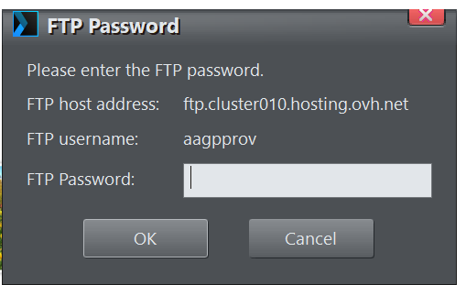 | Then just enter the password (see other document ‘AAGP Website’, FTP) and Xara will rumble away getting the pages ready (see moving bar in bottom left) then publish it (see moving bar at top right).  When it’s done the top right will say it’s been published and give you a link to the pages.  Remember to copy the xara files to server.

Note that on some peoples’ browsers old pages stored in “history” may appear so, when published, and when people complain of old pages appearing on their computer, its invariably their browser which needs to delete history / relevant cookies or both.

SEND EMAIL

FINALLY, finally, send an email (when the paper one arrives or on the 29th whichever happens first)
from your AAGP webmaster email address, enclosing reduced size pdf of:
- Newsletter, Large print Newsletter
  - (using reduced Mb size of each to keep mailing < 5Mb so all the older mailboxes can receive it
Go To Page 1
- , Large print Calendar (not standard one to save space)
- Large print Member changes (not standard one to save space)
to all electronic subscribers on
To: webmagsubscribers@aagp-provence.com The webmagsubscribers mailing list is not working properly so don’t use it anymore. Use the list of names placed in a word doc on the server with the Xara files and send them as Bcc so we don’t give out all email addresses – or at least they can’t be seen. In “To” use thewebmaster@aagp-provence.com …
Cc: membership@aagp-provence.com, newsletter@aagp-provence.com,
calendar@aagp-provence.com, smallads@aagp-provence.com, president@aagp-provence.com

Example:
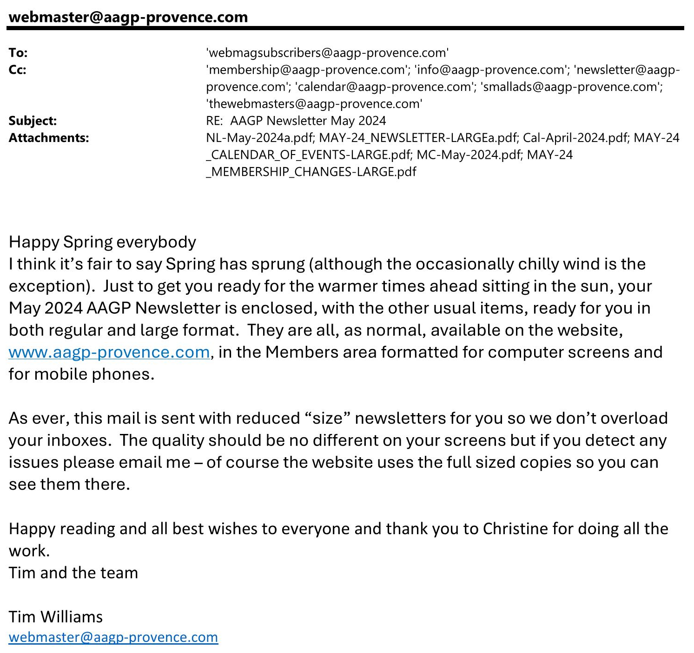
Bcc: use list on server
thewebmasters@aagp-provence.com
president@aagp-provence.com

ACCESS TO PRIVATE PAGES – PASSWORD PROTECTION
Put members pages data in www/Members where it will be behind the password
Password is selected each year in October by the Membership Secretary (Lish) who will publish it in the Membership Directory for the members to receive in November.

TO UPDATE PASSWORD:
Copy to your local directory, the file: ‘password.txt’ in “/access” folder on OVH Server (Filezilla);
Copy and paste ‘password.txt’ and rename copy ‘passwordOld.txt’ or use year: ‘password2023.txt’ ;
Open ‘password.txt’ in MS Notepad.
Go To Page 1
Go to this link to create new passwords https://www.web2generators.com/apache-tools/htpasswd-generator
We have 3 usernames because the username is case sensitive: ‘AAGP’, ‘Aagp’ and ‘aagp’.
Enter each username with the same password and click button ‘Generate.htpasswd file’
Copy Output to top of file to override old passwords. It is in the format username:password
You can keep old passwords in file as a record. The first occurrence of a username will be the one that is used.
Use filezilla to copy both files (password.txt and the old version) to server.
This will make it live. If the AAGP is not ready for the password change, rename the new one to passwordNew.txt or password(the year).txt and leave the old password.txt as is. When the AAGP is ready just rename the passwordNew.txt to password.txt
Then check it by opening browser in incognito (so there is no caching of password) and try it out.
More explanation of password file:
There is a folder, “/access” (not visible to web browsers), on the OVH server which contains a password file, password.txt. This file is maintained by the unix program htpasswd.
It contains Usernames and Password used to access the members’ private pages.
Capitalization counts on the Username, so there are three versions:
- all lower case,
- First Letter Capitalized,
- ALL CAPS.
To modify it, delete lines in a text editor (eg MS Notepad),
(or use a bash shell to add: navigate to the members directory where password.txt lives and type “htpasswd password.txt username” and it prompts for password and adds a line.)
Originally it contained:
cours:5vIE4ZzWyZXUs
Cours:ex.VKmZGrmyT6
Where ‘cours’ and ‘Cours’ were the usernames and the rest was the encrypted password.

The /www/members folder contains a file, .htaccess, which contains the following:
AuthName "Member's Section"
AuthType Basic
AuthUserFile /home/aagpprov/access/password.txt
Require valid-user
ErrorDocument 401 http://www.aagp-provence.com/errors/401.php
ErrorDocument 401 http://www.aagp-provence.com/errors/404.php

This causes the apache web server to challenge any user trying to access any file in the /www/members folder for a user name and password, valid ones being in the password.txt file.
HISTORY OF PASSWORDS
Go To Page 1
Nov 2025 it became AAGP and Heatwave

Nov 2024 it became AAGP and Songbird
Nov 2022 it became AAGP and Sunflower (same PW 2023)
Nov 2021 it became AAGP and Buttercup
Nov 2020 it became AAGP and Teapot
Oct 2019 it became AAGP and Abracadabra
Changed to AAGP Provence Oct 2018
Changed to King Kong 2017
…

EXAMPLEs of PASSWORD .txt FILE for 2023-4
In some years we left both years Username & Password in the file to allow a period of changeover – about a month in case older members still used the last year’s one. However as only one password is allowed for each Username, if the Username does not change this is not possible….

aagp:$apr1$mhvj5fgi$56jWlmiIczOPVGMPt46RB.
Aagp:$apr1$ftlxpk67$eG8p41Q5A6KU0LDiYKv81/
AAGP:$apr1$xlfkdmh8$QEhmgO3U9wAEX3O2sESDZ/
Songbird
Passwords below this line are not active until they replace the AAGP ones above
Note that the system takes the first match for a "user name" as it goes down
the list so only one password can be active for each exact username
these are the old ones:
aagp:$apr1$z7as4jlw$UlgmR1TQYGYKAmJ611pfQ0
AAGP:$apr1$omfgz9lk$jc.SqEIwVXNoERpdqX.Rx/
Sunflower

Passwords created at https://www.web2generators.com/apache-tools/htpasswd-generator

This is extra info – we do not have to create a new file as it already exists.

How to password protect a directory on your website (adapted from OVH)

1. Create the password file
Firstly, you have to create the file which will contain the list of usernames and passwords which are allowed to access the site. Usually, you create a .htpasswd file for this. In the AAGP site they are in a file named “password.txt”. This will then be used by the .htaccess file. It is a simple text file, which contains usernames and their encrypted passwords.
In Windows, you cannot directly create a file named .htaccess or .htpasswd. You must give it another name (eg htaccess.txt), transfer it to your web space and then rename it .htaccess or .htpasswd using your FTP client.
The .htpasswd should not necessarily be in the same location as the .htaccess file. For example, you could place it in the Webroot (the /www folder), and use it to protect different website directories, given that a single .htpasswd file can be used by several .htaccess files. The .htpasswd file and/or the “password.txt” filemust contain one line per user specifying the username and password.
These lines are as follows:
username:encrypted_password
Example for username: “Admin” and password: “ovh1234” this will give the following: Admin:gl0IiOirI2n6M
The encrypted version of the password can be generated here:
https://www.web2generators.com/apache-tools/htpasswd-generator
When the system reads the “password.txt” file to check for access rights it takes the first match for a "user name" as it goes down the list so only one password can be active for each exact username
Go To Page 1
Once the .htpasswd password has been created, you just have to place it in the “password.txt” file and go to the next step: creating .htaccess files.
Remember to add a carriage return after the encrypted password.

2. Create the .htaccess file
To block access to an entire directory, create a .htaccess text file as follows and place it into the directory you want to password protect.
IMPORTANT, In the following example, you have to replace your_ftp_username with your FTP username, you will find this in your control panel.
AuthUserFile /home/your_ftp_username/www/.htpasswd
AuthGroupFile /dev/null
AuthName "Restricted access"
AuthType Basic
require valid-user
In the example above, your .htpasswd file is located in the /www folder on your web server.

For AAGP .htaccess is placed in the /www/Members folder

AuthName "Members"
AuthType Basic
AuthUserFile /home/aagpprov/access/password.txt
Require valid-user
ErrorDocument 401 http://www.aagp-provence.com/errors/401.php
ErrorDocument 401 http://www.aagp-provence.com/errors/404.php

3. Block access to one or more specific files
To block access to one or more specific files, you just have to add the tags (one FILES tag per file):
<Files test.php>

AuthUserFile /home/your_ftp_login/www/.htpasswd
AuthGroupFile /dev/null
AuthName "Restricted access"
AuthType basic
require valid-user

</Files>

Go To Page 1
AAGP GROUP MAILING LISTS
Google Workspace account admin: webmaster@aagp-provence.com
domain to set up the account: aagp-provence.com
secondary email address: timinaix@gmail.com

username to sign into your Google Workspace: webmaster@aagp-provence.com
Password: Rhubarb999

Google will store this number and only use it for security purposes.: +33 672827277

The address for the My Groups page is:
https://groups.google.com/u/1/my-groups

The address for the Admin Console is:
https://admin.google.com/u/1/ac/home?journey=218

The note from Google was:
Welcome to your new account
Welcome to your new account: webmaster@aagp-provence.com. Your aagp-provence.com administrator decides which Google Workspace and other Google services you may access using this account.
Your organization administrator manages this account and any Google data associated with this account (as further detailed here). This means that your administrator can access and process your data, including the contents of your communications, how you interact with Google services, or the privacy settings on your account. Your administrator can also delete your account, or restrict you from accessing any data associated with this account.
If your organization provides you access to administrator-managed services, like Google Workspace, your use of those services is governed by your organization’s enterprise agreement. Besides these terms, we also publish a Google Cloud Privacy Notice.
If your administrator enables you to use other Google services besides Google Workspace while logged in to this webmaster@aagp-provence.com account, your use of those services will be governed by their respective terms, such as the Google Terms of Service and the Google Privacy Policy and other service-specific Google terms. If you do not agree to these terms, or do not wish Google to handle your data in this way, do not use those other Google services with this webmaster@aagp-provence.com account. You may also customize your privacy settings at myaccount.google.com.
Your use of Google services with this account is also governed by your organization’s internal policies.

Users of the Group.
We are all registered users. That means we can sign in and manipulate the groups. Here are the logins:

First & Last name | Primary email address | Secondary email address  Secondary emails are used to send sign-in instructions | Password
Tim Williams | webmaster@aagp-provence.com | tim@ringsteadbay.com | Rhubarb999
Christine Chang | webmaster-2@aagp-provence.com | christine@mcchang.com | 9Y229aP&
KC King | webmaster-3@aagp-provence.com | kc.king@hotmail.fr | THm94rK>
Go To Page 1
GROUPS

AAGP-Board
Group Description: AAGP Board – private
Group email: board@aagp-provence.com
Group owners: webmaster@aagp-provence.com
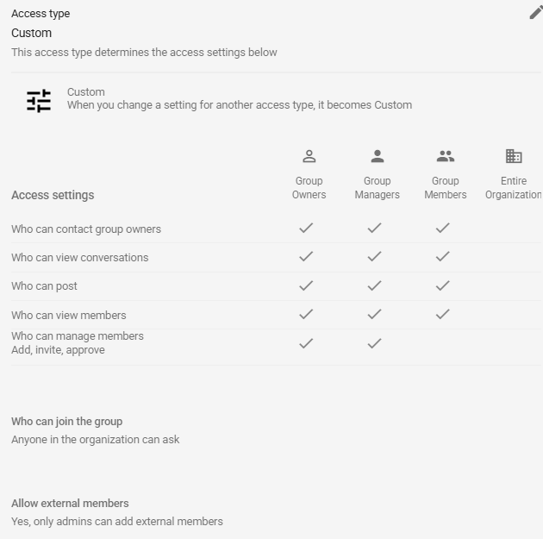

AAGP-Newsletter
Group Description: AAGP Newsletter editors
Group email: newsletter@aagp-provence.com
Group owners: webmaster@aagp-provence.com
Go To Page 1
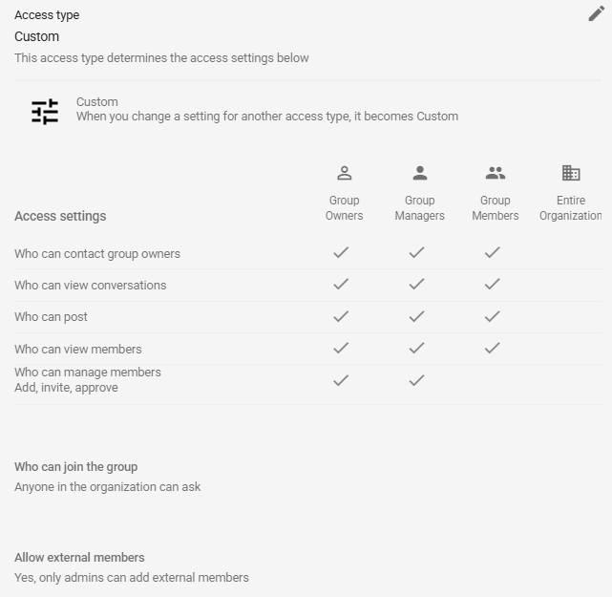

The Webmasters
Group Description: AAGP Webmasters
Group email: thewebmasters@aagp-provence.com
Group owners: webmaster@aagp-provence.com
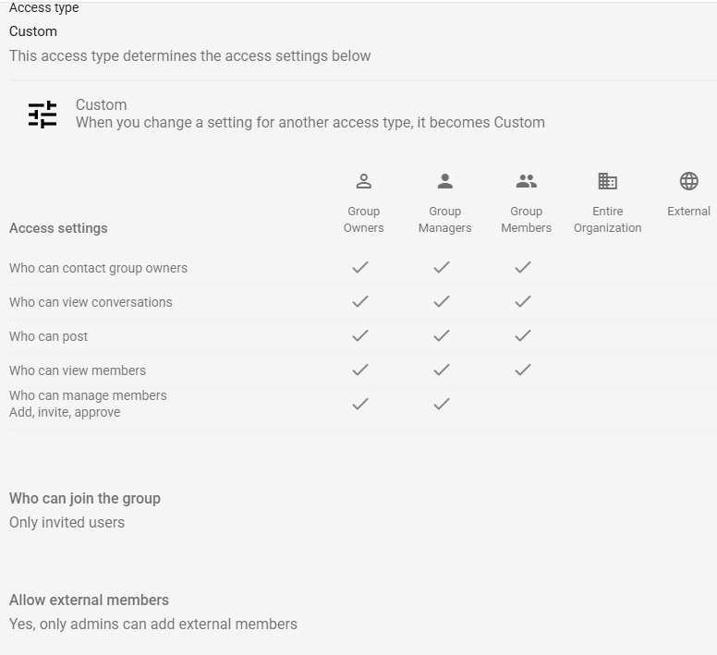

Online Newsletter Subscribers
Group Description: Those who have elected to receive their monthly newsletter via email mailshot
Group email: webmagsubscribers@aagp-provence.com
Group owners: webmaster@aagp-provence.com
Go To Page 1
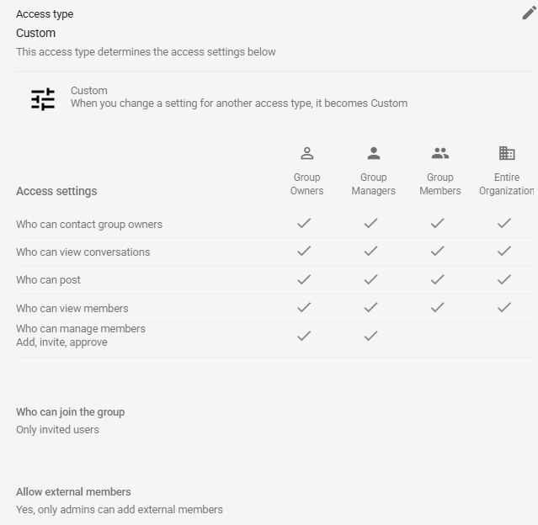

Admin of the members lists is done on the ADMIN CONSOLE site (see top of this section for the address)

Updating Group Members
Under ADMIN CONSOLE https://admin.google.com/u/1/ac/home?journey=218
Click on “Groups”. Hover over the group name and, to the right, a list of actions appears. Select “Manage Members”. You can add individuals or lists / groups.
To load lists of members for each list, I made a CSV file of 4 columns for each list uploaded that.

To be allowed to add individuals email addresses the list must permit the addition of “External Users Not Managed By Admin” (the little yellow icon by each name once loaded, shows that). That setting is under the same group list page in the menu on the left – click “ACCESS SETTINGS”. Use the “edit” pencil a the top right of the “Access Type” section and under “Allow external members” check the box for “Allow admins to add external members”

To set or update the settings for each individual Group you will need the GROUPS page at https://groups.google.com/u/1/my-groups

Click on “My Groups”. Then click on the Group you want to work on.
At the bottom left of the page is “Group Settings”. Click on that and you have all the options.
NB. I had a problem when the AI put this page on the same window as the AI. I could not scroll it towards the bottom enough to access the “SAVE” button! I had to open it in its own tab/window on the browser.

There are a number of settings I have placed there such as the footer “To reply to everyone, please use Reply-all.” On the Board, Newsletter and Thewebmasters lists.

I made a reasoned judgement on the settings with some AI guidance but I am sure some adjustments will be necessary. Make the changes you need but do consider making changes to all the lists , or not if not warranted for a particular list!.

To use a new group with the OVH email address, just make sure there is a mailing address for the group created in OVH and that it‘s diversion/forwarding is to the equivalent of these:
Go To Page 1
OVH address | Forward to
board@aagp-provence.com | board@aagp-provence.com.test-google-a.com
newsletter@aagp-provence.com | newsletter@aagp-provence.com.test-google-a.com
webmagsubscribers@aagp-provence.com | webmagsubscribers@aagp-provence.com.test-google-a.com
thewebmasters@aagp-provence.com | thewebmasters@aagp-provence.com.test-google-a.com

All the normal mail addresses will be handled by OVH as usual but by diverting these mailing lists to the … test-google-a.com address and making the DNS change as advised by AI / Google, the system will activate the group mailing list distribution and forward a mail sent to it to all the members of that group.
Go To Page 1

AI advice on the first question and then updated. I include it here as a reference:

Perfect, I’ll walk you through exactly how to set up Google Groups using your domain aagp-provence.com for free, using Google Cloud Identity Free. This gives you:
- A proper group email address (e.g., newsletter@aagp-provence.com)
- Replies go to the entire group
- Maximum deliverability (Google’s SPF/DKIM/DMARC)
- No paid Google Workspace subscription
- No marketing-sender limitations
This is the cleanest, most reliable way to run a discussion mailing list.

🧭 Step-by-step setup for Google Groups using your domain

1. Create a free Google Cloud Identity account
You do not need paid Google Workspace.
- Go to: https://workspace.google.com/signup/gcpidentity (workspace.google.com in Bing)
- Choose Cloud Identity Free
- Enter your domain: aagp-provence.com
- Create your admin account (e.g., admin@aagp-provence.com)
- Log into the Google Admin Console: https://admin.google.com
This gives you a free Google organization with your domain.

2. Verify your domain
Google will ask you to add a TXT record to your DNS.
If your domain is hosted somewhere like OVH, IONOS, Cloudflare, GoDaddy, etc., you’ll add:
- A TXT record with the verification string Google provides.
Once added, click Verify in the Google Admin Console.

3. Enable Google Groups for Business
This is required for discussion lists.
Inside the Admin Console:
- Go to Apps
- Google Workspace
- Groups for Business
- Turn it ON for everyone
This unlocks full mailing-list functionality.

4. Create your group
Now create the actual mailing list:
- Go to: https://groups.google.com/a/aagp-provence.com/forum/#!myforums (groups.google.com in Bing)
- Click Create Group
Use these settings:
Group name: AAGP Newsletter
Group email: newsletter@aagp-provence.com
Group type: Choose Collaborative Inbox or Email List (both support reply-to-all behaviour)
Posting permissions:
Set:
- Who can post: Group members
- Who can view conversations: Group members
- Who can join: Only invited users (recommended)
Reply behaviour:
Under Settings → Email options Set:
- Post replies to: Entire group
This is the key setting that makes replies go to all 100 members.
Go To Page 1

5. Add your members
You can add up to hundreds of members for free.
In the group:
- Go to Members
- Click Add members
- Paste your list of email addresses
- Choose Direct add (so they don’t need to accept an invite)

6. Set up SPF, DKIM, and DMARC for maximum deliverability
Google provides the records inside:
Admin Console → Apps → Google Workspace → Gmail → Authenticate email
Add these DNS records:
SPF
Code
v=spf1 include:_spf.google.com ~all
DKIM
Google will generate a DKIM TXT record like:
Code
google._domainkey.aagp-provence.com
Add the TXT value Google provides.
DMARC
Add a TXT record:
Code
_dmarc.aagp-provence.com
v=DMARC1; p=quarantine; rua=mailto:postmaster@aagp-provence.com
You can change p=quarantine to p=reject later once everything is stable.
7. Test deliverability
Send a test email from: newsletter@aagp-provence.com
To:
- A Gmail address
- A Yahoo address
- An Outlook address
In Gmail, open the message → Show original You should see:
- SPF: PASS
- DKIM: PASS
- DMARC: PASS
This is Google-grade deliverability — the best you can get.

🎉 You now have a fully functional, high-deliverability group mailing list
You can send one email to newsletter@aagp-provence.com, and:
- All 100 members receive it
- Anyone can reply
- Replies go to the entire group
- SPF/DKIM/DMARC ensure your mail avoids spam filters
- Everything is free

If you want, I can:
- Generate the exact DNS records for your DNS provider
- Help you configure reply-to-all behaviour perfectly
- Help you add your first 100 members
- Help you test deliverability
Just tell me who hosts your DNS (Cloudflare, OVH, IONOS, GoDaddy, etc.).

Go To Page 1

